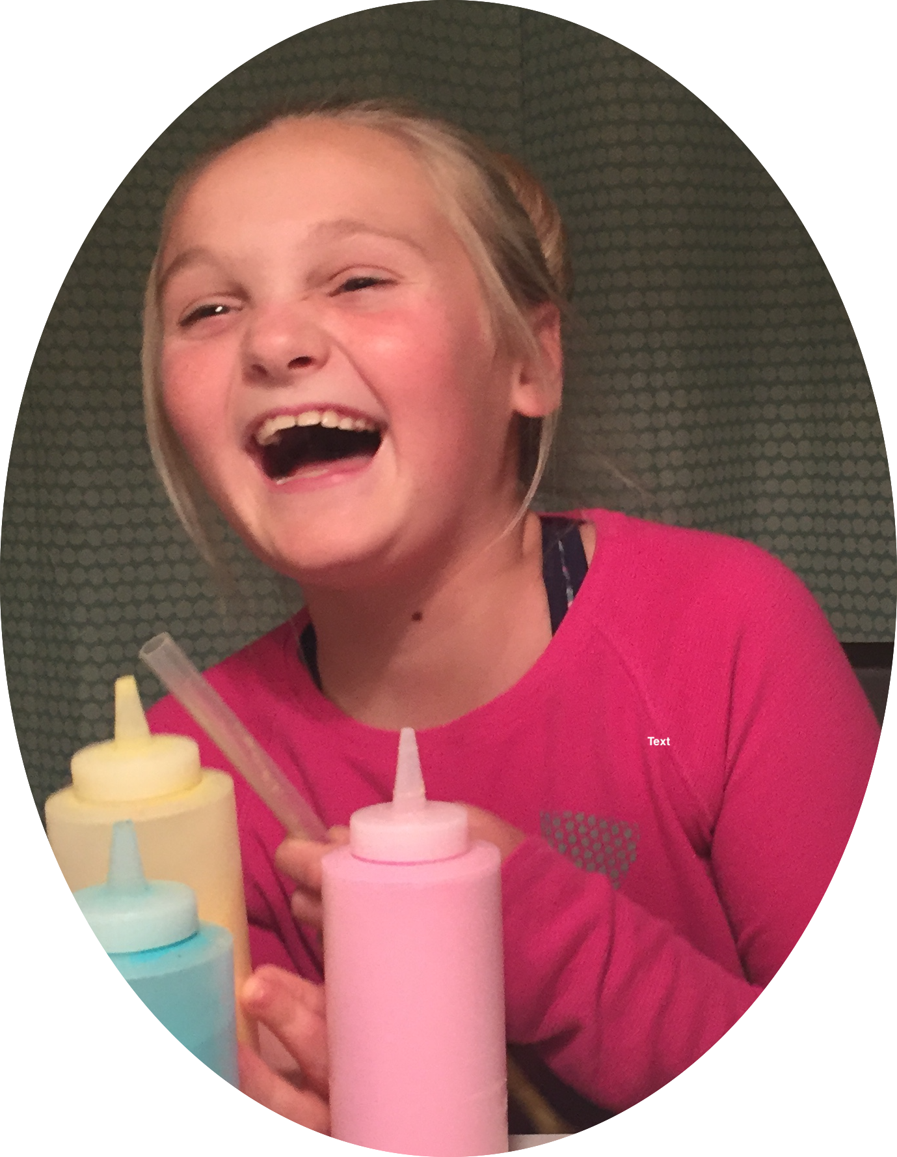
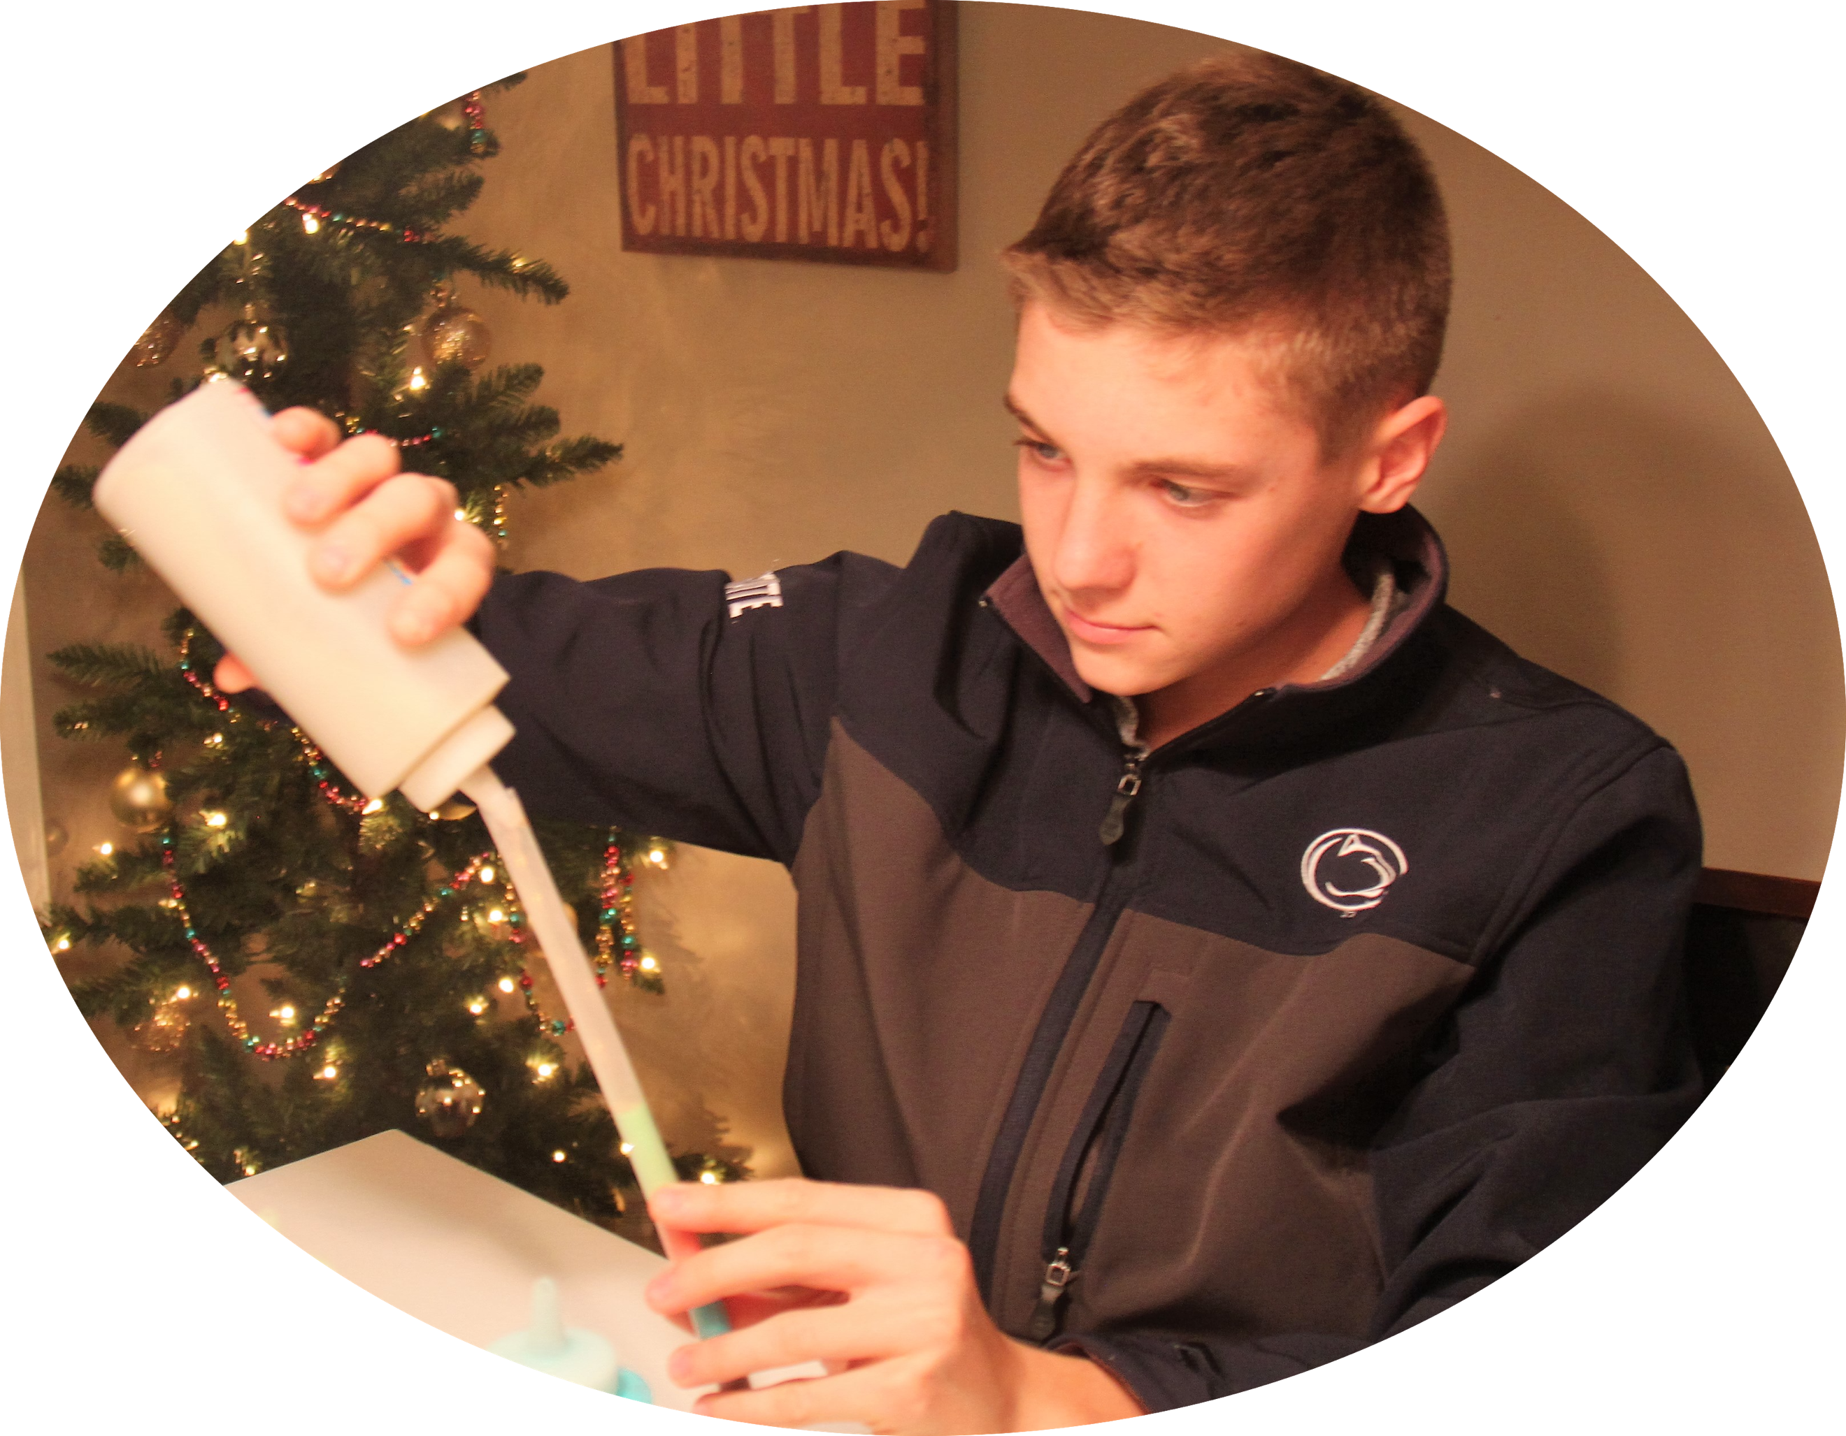
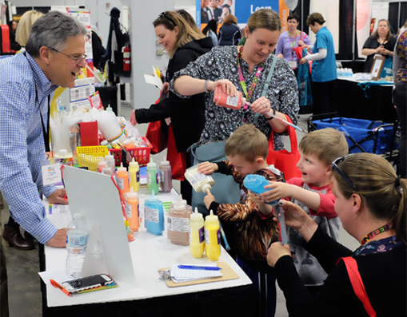
ADVICE FOR NEXT TIME!
I am providing the following advice for future volunteers

If you have any questions, please feel free to contact me. My contact information is:

Name ______________ Best way to reach me: __________________________
We used from

At [Event]: ____________________ Date of event ______________,

Contact information for SandCrafters:
info@sandcrafters.com
www.sandcrafters.com
(800) FUN SAND (800.386.7283)
What is Candy Art? It’s a make your own pixie stick! Each color is a unique flavor — some sweet, some sour! Layer the different flavors and colors into a clear plastic straw from 4 to 104! It’s popular with all school levels – even high school and college!
It’s an activity. It’s a treat. As much fun to make as it is to eat!
Fall Festival | ❖ | ANY Fundraiser | ❖ | Carnivals Festivals | ❖ | Relay for Life
Color Runs | ❖ | Back to School | ❖ | Diversity Activity | ❖ | Movie Night
Spring Fair | ❖ | Trunk or Treat | ❖ | Ice Cream Social | ❖ | Rewards
Field Day | ❖ | Athletic Event | ❖ | Family Fun Night | ❖ | Dance

Overall, our experience was ______________________
We bought _________ tubes for $__________
We used it as a fundraiser, and we sold it for _________ per tube and we made $__________
We used it as a reward/incentive for ___________
We used it just for FUN
Order by number of tubes, and they determine how much candy we need
We can choose our flavors, or they can recommend
We bought the following flavors: ________________________________________________

How we paid:_________________

Next time I would buy: __________________

Best news:
[ ] Low sugar content
[ ] Free of the 8 major allergens, gluten-free, kosher, gelatin-free
[ ] As much FUN to make as it is to eat
[ ] EASY
[ ] PROFITABLE
[ ] OTHER:

Things that helped make the event successful:
[ ] Used Tip Sheet
[ ] Advertised/promoted before the event using artwork from SandCrafters
[ ] Used artwork from SandCrafters at the event to demonstrate low sugar/allergen-free
[ ] Cut the nozzles before the event
[ ] OTHER:

Other points to consider

______________________________________________________________________________

______________________________________________________________________________

