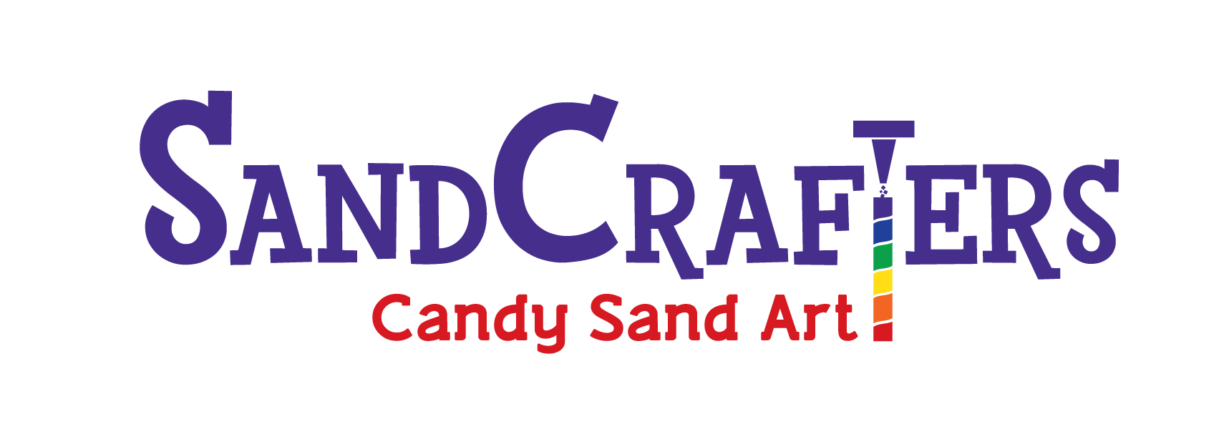
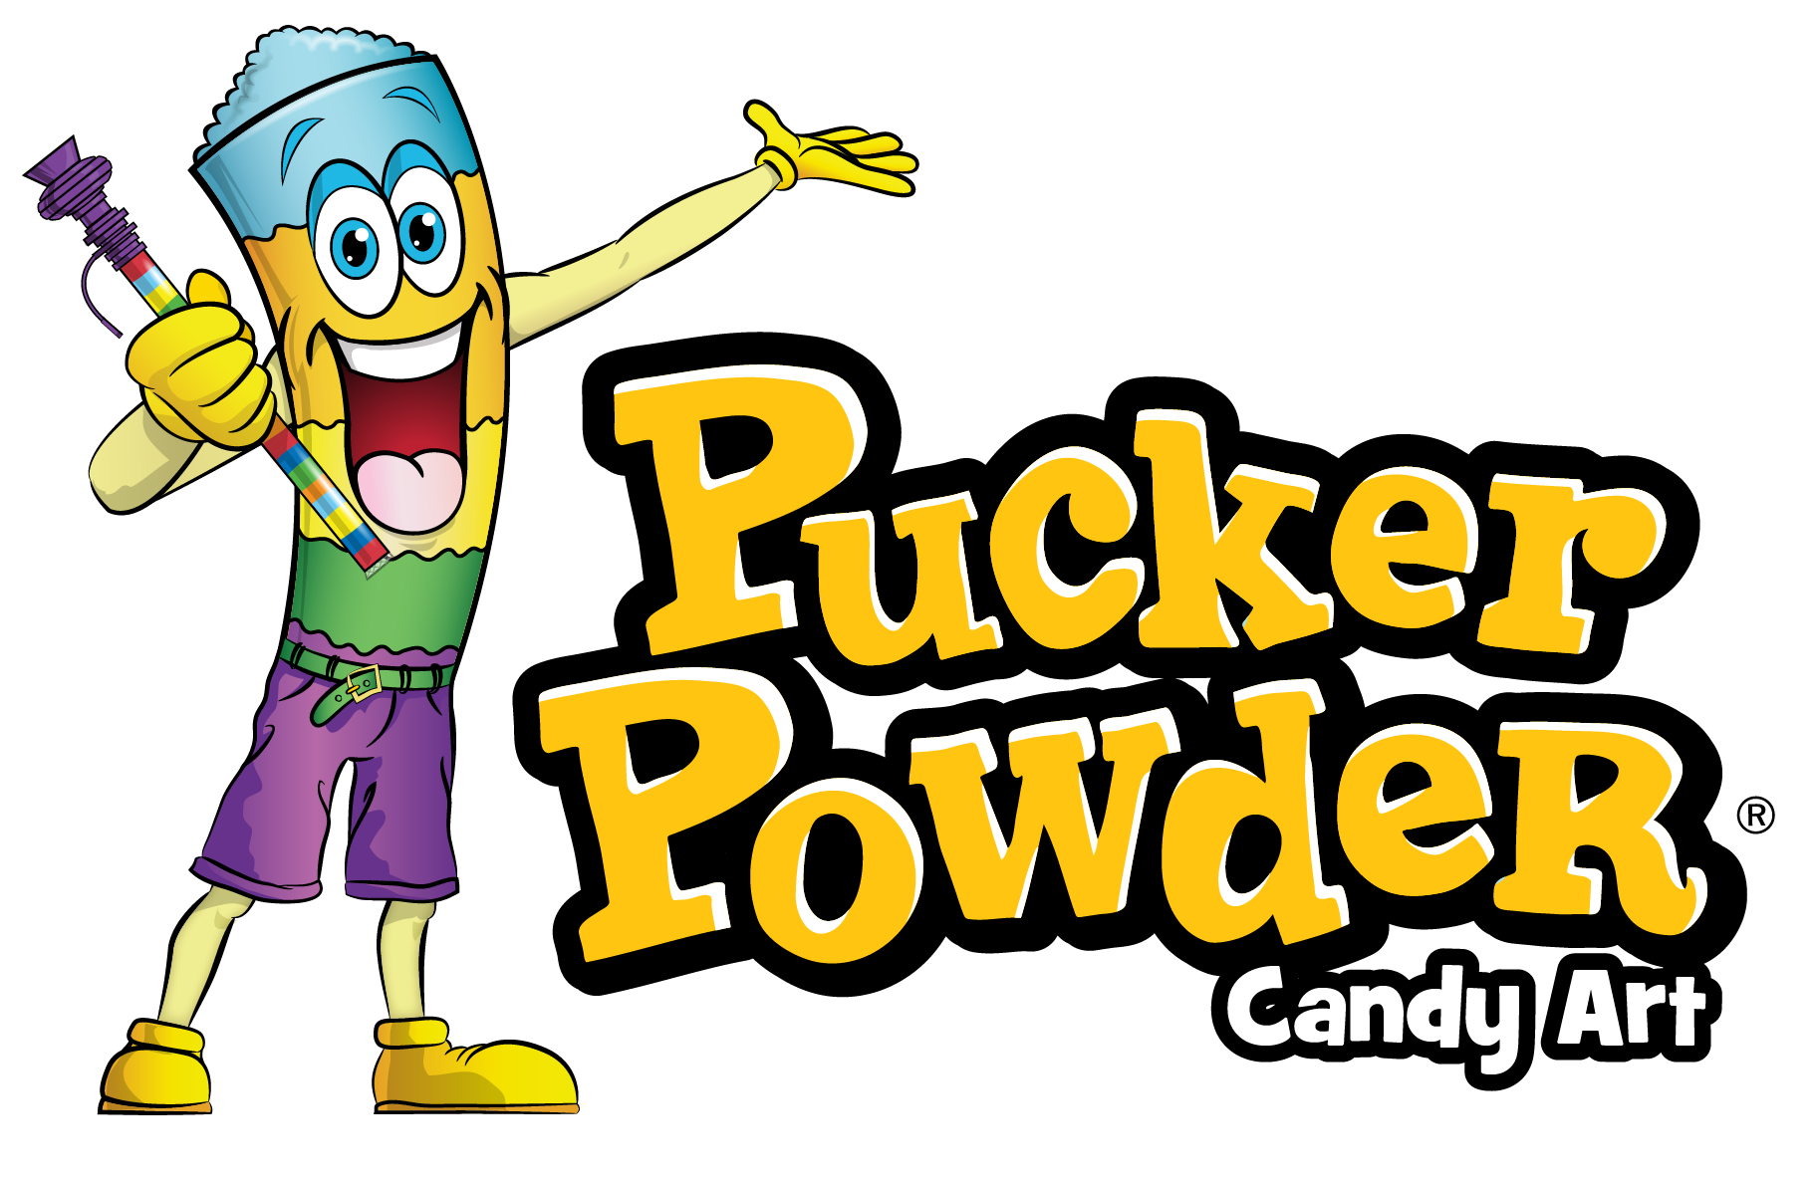

Crafting fun for over 25 YEARS!

FUN… EASY… PROFITABLE
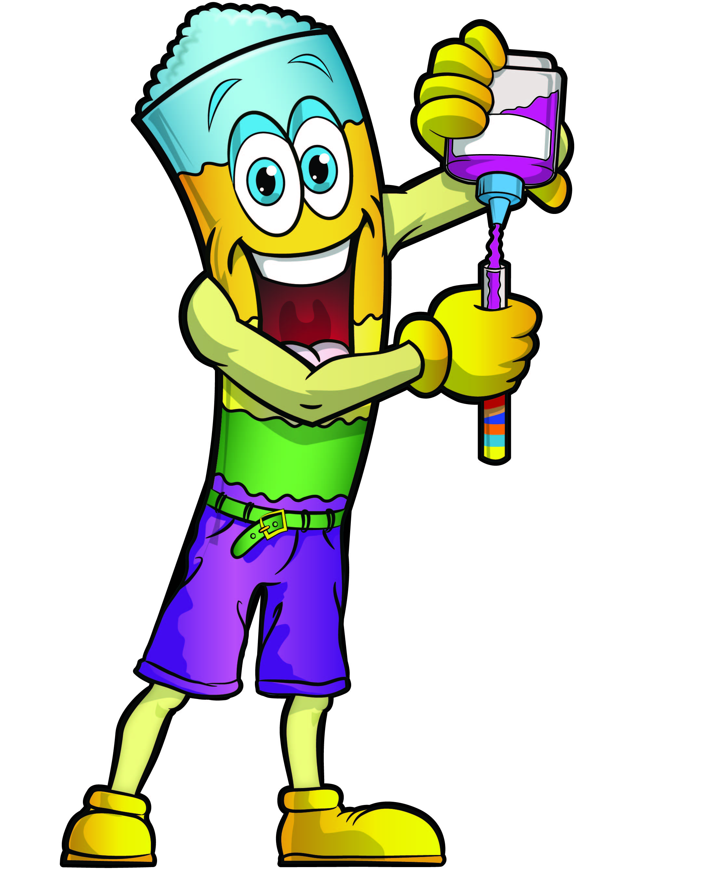
SandCrafters Candy Art is a hands-on, engaging activity for all ages 4 to 104! Make your own pixie stick. Simple to add to any event. It is an activity and a treat – as much FUN to make as it is to eat. Easy set-up & clean-up.

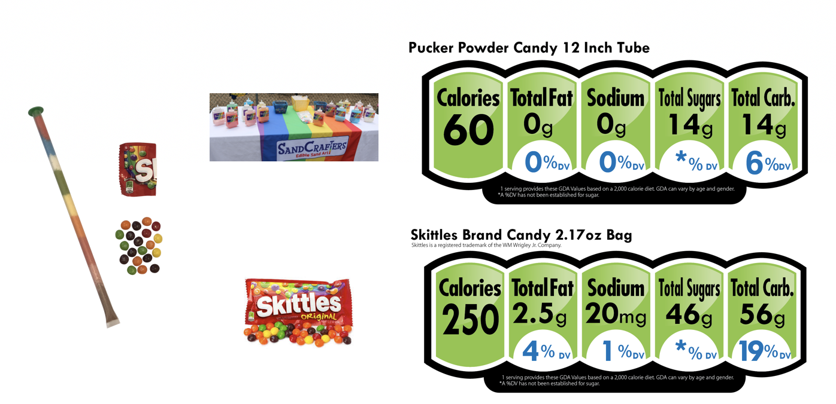
LOW SUGAR CONTENT: A 12" straw contains only 14 grams of sugar - less than 1/3 the sugar in a bag of Skittles.
Holiday Favorite
Halloween
Christmas
Valentines
Purim
Easter
Independence Day
Simchat Torah

- SAFETY first
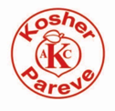
- Free of ALL 9 major allergens (made in a facility free of peanuts, tree nuts, dairy, eggs, wheat, soy, fish, shellfish, sesame), gluten-free, gelatin-free and kosher.
- Manufactured in an FDA-compliant facility in the USA
- Bottles are safety-sealed and labels include nutritional information and ingredients
unique to each flavor, including food dye
- Straws and caps are factory sealed
- No need to wonder about product age - each bottle is clearly marked with the Production Date AND Best-Used-By Dates
- No prepayment required: Net 20 terms are available for our school customers - hold your event, collect the money and then pay the bill.
- Orders can be shipped within 24 hours or held until close to your event date
- Prices include the bottles of candy – always more than enough!
- Customize your flavors: Pick your own flavors, or leave it to us, and we will send a combination of the most popular flavors and colors.
- Flexible order quantity: Minimum order is 90 straws and then multiples of 30's
- PROFITABLE: Make 50% to 75% profit or MORE
- SandCrafters can provide artwork for newsletters, posters, announcements, etc.

To learn more about SandCrafters edible sand art products, visit our website, give us a call at 1.800.FUN.SAND (800.386.7263), or send an email. Order online, by phone or complete an order form and fax/email/mail to us.

About SandCrafters: SandCrafters has been in operation for over 20 years, started by a mom who began as a volunteer running sand art tables at school fairs and other community events. We have first-hand experience to be able to relate to our customers. SandCrafters is now a family run business focused on providing Fun, Easy & Profitable crafts. We have become the leading distributor of edible sand art to schools, communities, hotels, camps, entertainment companies, religious organizations and other businesses.

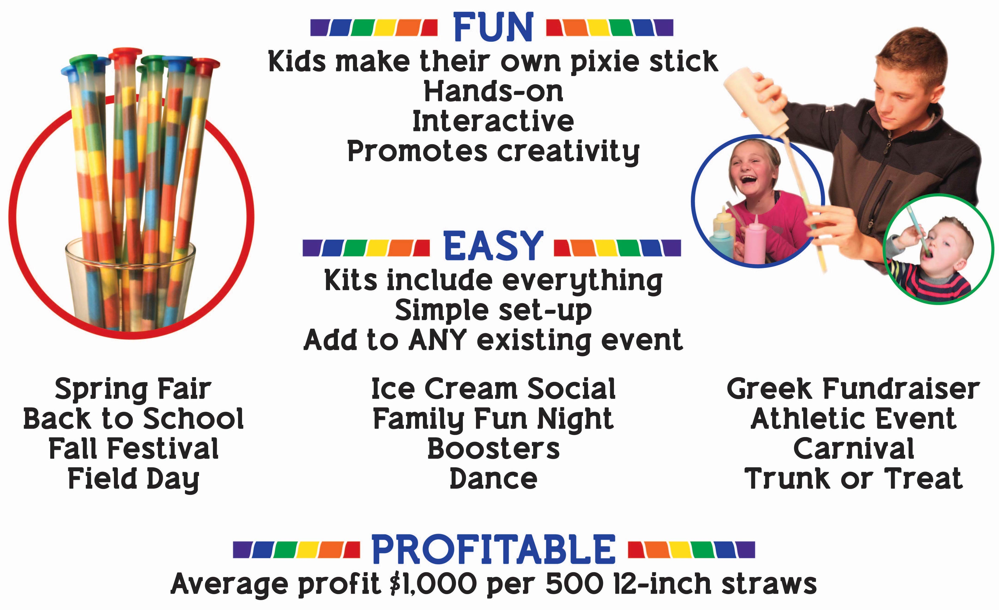

6" Straws  Sample Profit |  | 12" Straws  Sample Profit |  | 18" Straws  Sample Profit
510 Straws  17 Bottles |  | 510 Straws  34 Bottles |  | 510 Straws  51 Bottles
Buy for: | $1.05 each | Buy for: | $1.30 each | Buy for: | $1.50 each
Sell for: | $3.00 each | Sell for: | $5.00 each | Sell for: | $6.00 each
Cost: | $ 535.50 | Cost: | $ 663.00 | Cost: | $ 765.00
Sales: | $ 1,530.00 | Sales: | $ 2,550.00 | Sales: | $ 3,060.00
Profit: | $ 994.50 | Profit: | $ 1,887.00 | Profit: | $ 2,295.00

